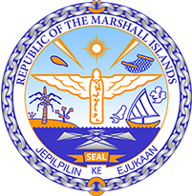

Republic of the Marshall Islands
STATEMENT by Mr. Samuel Lanwi Jnr
45th Session Universal Periodic Review
22nd January – 2nd February 2024
Geneva

4th Cycle Review of China

The Marshall Islands welcomes the delegation of China to this 4th UPR Cycle and continued engagement in The Council’s work.

We recommend the following for consideration:
- Implement the recommendations of the CESCR to align with the Paris Agreement by increasing taxation of emissions, suspending ongoing financing for coal-fired power plants, and replacing fossil fuel by increasing renewable energy.
- Implement the recommendations of CEDAW and CESCR by putting an end to sexual and gender-based violence against women of ethnic minorities and allowing full enjoyment of their cultural rights and right to education.
- In line with the Terms of Reference for Special Procedures visits, grant unrestricted access to visits from Special Procedures and the High Commissioner.
- Implement the Concluding Observations of CEDAW and CRPD recommending to immediately stop reprisals against human rights defenders, journalists, and individuals belonging to minority groups.
- Adopt a human rights-based approach in its development and cooperation policies.

We wish the delegation every success during its 4th UPR cycle.

Kommol tata and I thank you Mr. President.

