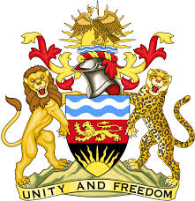

**REPUBLIC OF MALAWI**

**MALAWI STATEMENT ON THE REPUBLIC OF CHINA UNIVERSAL PERIODIC REVIEW**

**TUESDAY, 23RD JANUARY 2024**

**Mr. President**,

Malawi welcomes China to this review and we thank the delegation for the comprehensive presentation.

Malawi notes the progressive steps taken by China in the promotion and protection of the human rights. These include the adoption National Human Rights Action Plan (2021–2025), the Outline for Women’s Development (2021–2030), the Outline for Children’s Development (2021–2030), and the Development Plan for Persons with Disabilities under the Fourteenth Five Year Plan.

We make the following recommendations to China

1. Continue with a people centred approach in the promotion and protection of human rights
2. Continue taking all measures to implement the Human Rights Action Plan 2021-2025
3. Continue taking all measures to promote the rights of persons with disabilities.

We wish China all the best at this review and in the implementation of the recommendations.

**Thank you, Mr. President**.