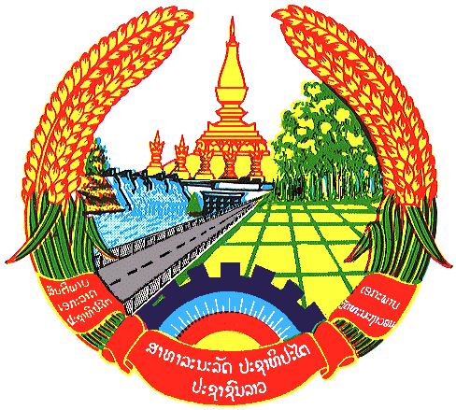

**Statement by the delegation of the Permanent Mission of the Lao PDR to the United Nations and other International Organizations in Geneva**

**at the 45th Session of UPR Working Group**

**Geneva, 23 January 2024**

(Speaking time 0.45 minute)

Review of China (09:00 - 12:30)

1. Thank you, Mr. President, for the floor.
2. The Lao PDR warmly welcomes the delegation of China and thanks them for the comprehensive report.
3. My delegation commends China for the significant progress made in advancing human rights endeavours, its socio-economic development, China’s positive contributions to the UN Human Rights Council and its adhering to a people-centred philosophy of human rights.
4. The Lao PDR would like to make 2 following recommendations:
5. Continue to deepen comprehensive and integrated reform of the judicial system and faithfully enforce judicial accountability; and
6. Continue to improve the capacity for disaster prevention, mitigation, relief and response to major public emergencies.
7. We wish China a success in this UPR cycle review.
8. I thank you, Mr. President.