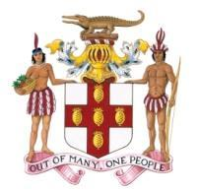

**STATEMENT**

**by**

**the Government of Jamaica**

**during**

**the 45th Session of the Universal Periodic Review and fourth review cycle of the People’s Republic of China**

**United Nations, Geneva**

**23rd January 2024**

*Please check against delivery*

Mr. President,

Jamaica warmly welcomes the delegation of The People’s Republic of China to today’s UPR exercise, and thanks them for their comprehensive presentation.

We commend the delegation on the progress in the implementation of the recommendations accepted during the Third UPR Cycle.

My delegation notes positively that China has recorded robust social and economic development. We note further that through the implementation of its poverty alleviation strategy, the welfare of approximately 100 million rural poor has been improved. Additionally, we welcome efforts made to improve the situation of vulnerable groups including the elderly, women, children and the disabled, as well as initiatives aimed at improving the health of citizens throughout their life cycles.

We support the Government’s efforts to implement other reforms including those to safeguard the right of lawyers to practice law and improve their participation in the litigation system[1].

We wish the delegation of the People’s Republic of China every success for this UPR process.

I thank you.

1. See Section B Civil and Political Rights – no.3 Right to a fair trial: paragraph 40 (page 8 of the Government’s report).