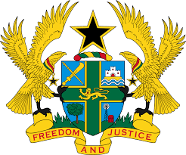

**STATEMENT BY GHANA DELIVERED BY H.E. EMMANUEL ANTWI, AMBASSADOR AND PERMANENT REPRESENTATIVE, DURING THE 45TH SESSION OF THE UPR WORKING GROUP ON TUESDAY, 23RD JANUARY, 2024**

**UNIVERSAL PERIODIC REVIEW OF CHINA**

Mr. President.

Ghana welcomes the delegation of China to the 4th UPR cycle and commends China for its efforts towards the promotion of socio-economic development, poverty reduction, increased access to education and healthcare as well as adherence to the rule of law and social justice. We also applaud the incorporation of human rights education in the curricula of primary and secondary schools.

In the spirit of constructive dialogue, Ghana recommends that China:

1. **Maintain its constructive engagement and collaboration with international human rights mechanisms with the view to building on the progress achieved in previous UPR cycles; and**
2. **Continue the implementation of the Convention on the Rights of Persons with Disabilities and strengthen the creation of literary and artistic works for persons with disabilities.**

We wish China a very successful review process.

I thank you.