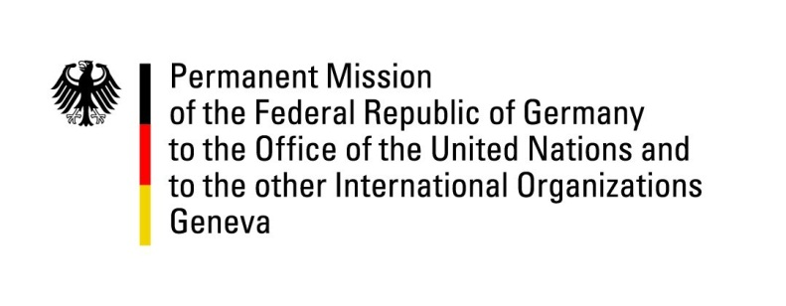

**United Nations Human Rights Council**

**45th Session of the UPR Working Group**

**Geneva, 23rd of January 2024**

**German Recommendations and advance questions to**

**China**

Mister President,

Germany welcomes the Chinese delegation, commending the amendments to the Law on the Protection of Women’s Rights and Interests.

Germany remains highly concerned about serious human rights violations especially in Xinjiang and Tibet.

Germany recommends to:

* Revoke all laws restricting freedoms of expression and assembly;
* Cease all reprisals against human rights defenders and civil society organizations;
* Implement all recommendations of the OHCHR report on Xinjiang and of UN treaty bodies;
* Respect the rights of persons belonging to ethnic and religious minorities, including in Xinjiang and Tibet
* Restore full respect for the rule of law and civil and political rights in Hong Kong
* Abolish all coercive practices in labor transfer programs and boarding schools;
* Adopt anti-discrimination legislation relating to diverse sexual orientations and gender identities;
* Release all human rights defenders from arbitrary detention, including from the “709” and “Xiamen” crackdowns;
* Abolish all forms of enforced disappearance including via residential surveillance at a designated location;
* Adopt a moratorium on executions.

Thank you, Mister President.