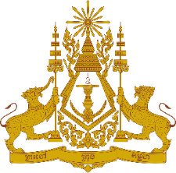

**PERMANENT MISSION OF THE KINGDOM OF CAMBODIA**

**TO THE UNITED NATIONS AT GENEVA**

**Statement of Cambodia**

At the 45th Session of the UPR Working Group

UPR of the People’s Republic of China

23 January 2024

00:45 second

-------

Mr. President!

1. Cambodia warmly welcomes the distinguished delegation of the People’s Republic of China.
2. We commend efforts made by China in achieving the UN 2030 Agenda’s poverty alleviation goals ahead of schedule and significantly contributing to global poverty reduction and human development.
3. In the constructive spirit, we recommend the following:
   1. Take additional steps to enhance the agricultural science and technology innovation system and broaden access to agricultural technology services through innovative approaches.
   2. Continue efforts to effectively improve workers’ skills, elevate employment quality and income level.
4. Finally, I wish the delegation of China a successful review.

Thank you,

*\*\*\*\*\**