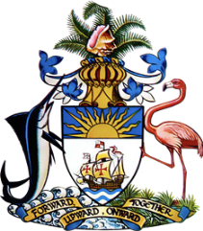

**Statement by Ms. Sasha Dixon, Counsellor  
 Permanent Mission of The Bahamas to the United Nations Office and other International Organizations in Geneva**

**at the 44th Session of the Universal Periodic Review Working Group**

***Presentation of UPR Report by the People's Republic of China*23January 2024**

Thank you, Mr. President,

The Bahamas thanks the People's Republic of China for its comprehensive national report and commends progress made since the last review cycle.

We positively note China's commitment to human rights both at the national level, as evident in the establishment of initiatives such as the National Programme for Poverty Alleviation, and, internationally, such as through the Global Development and South-South Cooperation Fund.

In a constructive spirit, The Bahamas recommends that China:

1. Consider extending a standing invitation to all thematic special procedures of the Human Rights Council (HRC)
2. Build on plans outlined in the national report to reduce CO2 emissions before 2030 and achieve carbon neutrality before 2060 in the collective fight against the impacts of climate change.

We wish the People’s Republic of China a successful review.

I thank you.