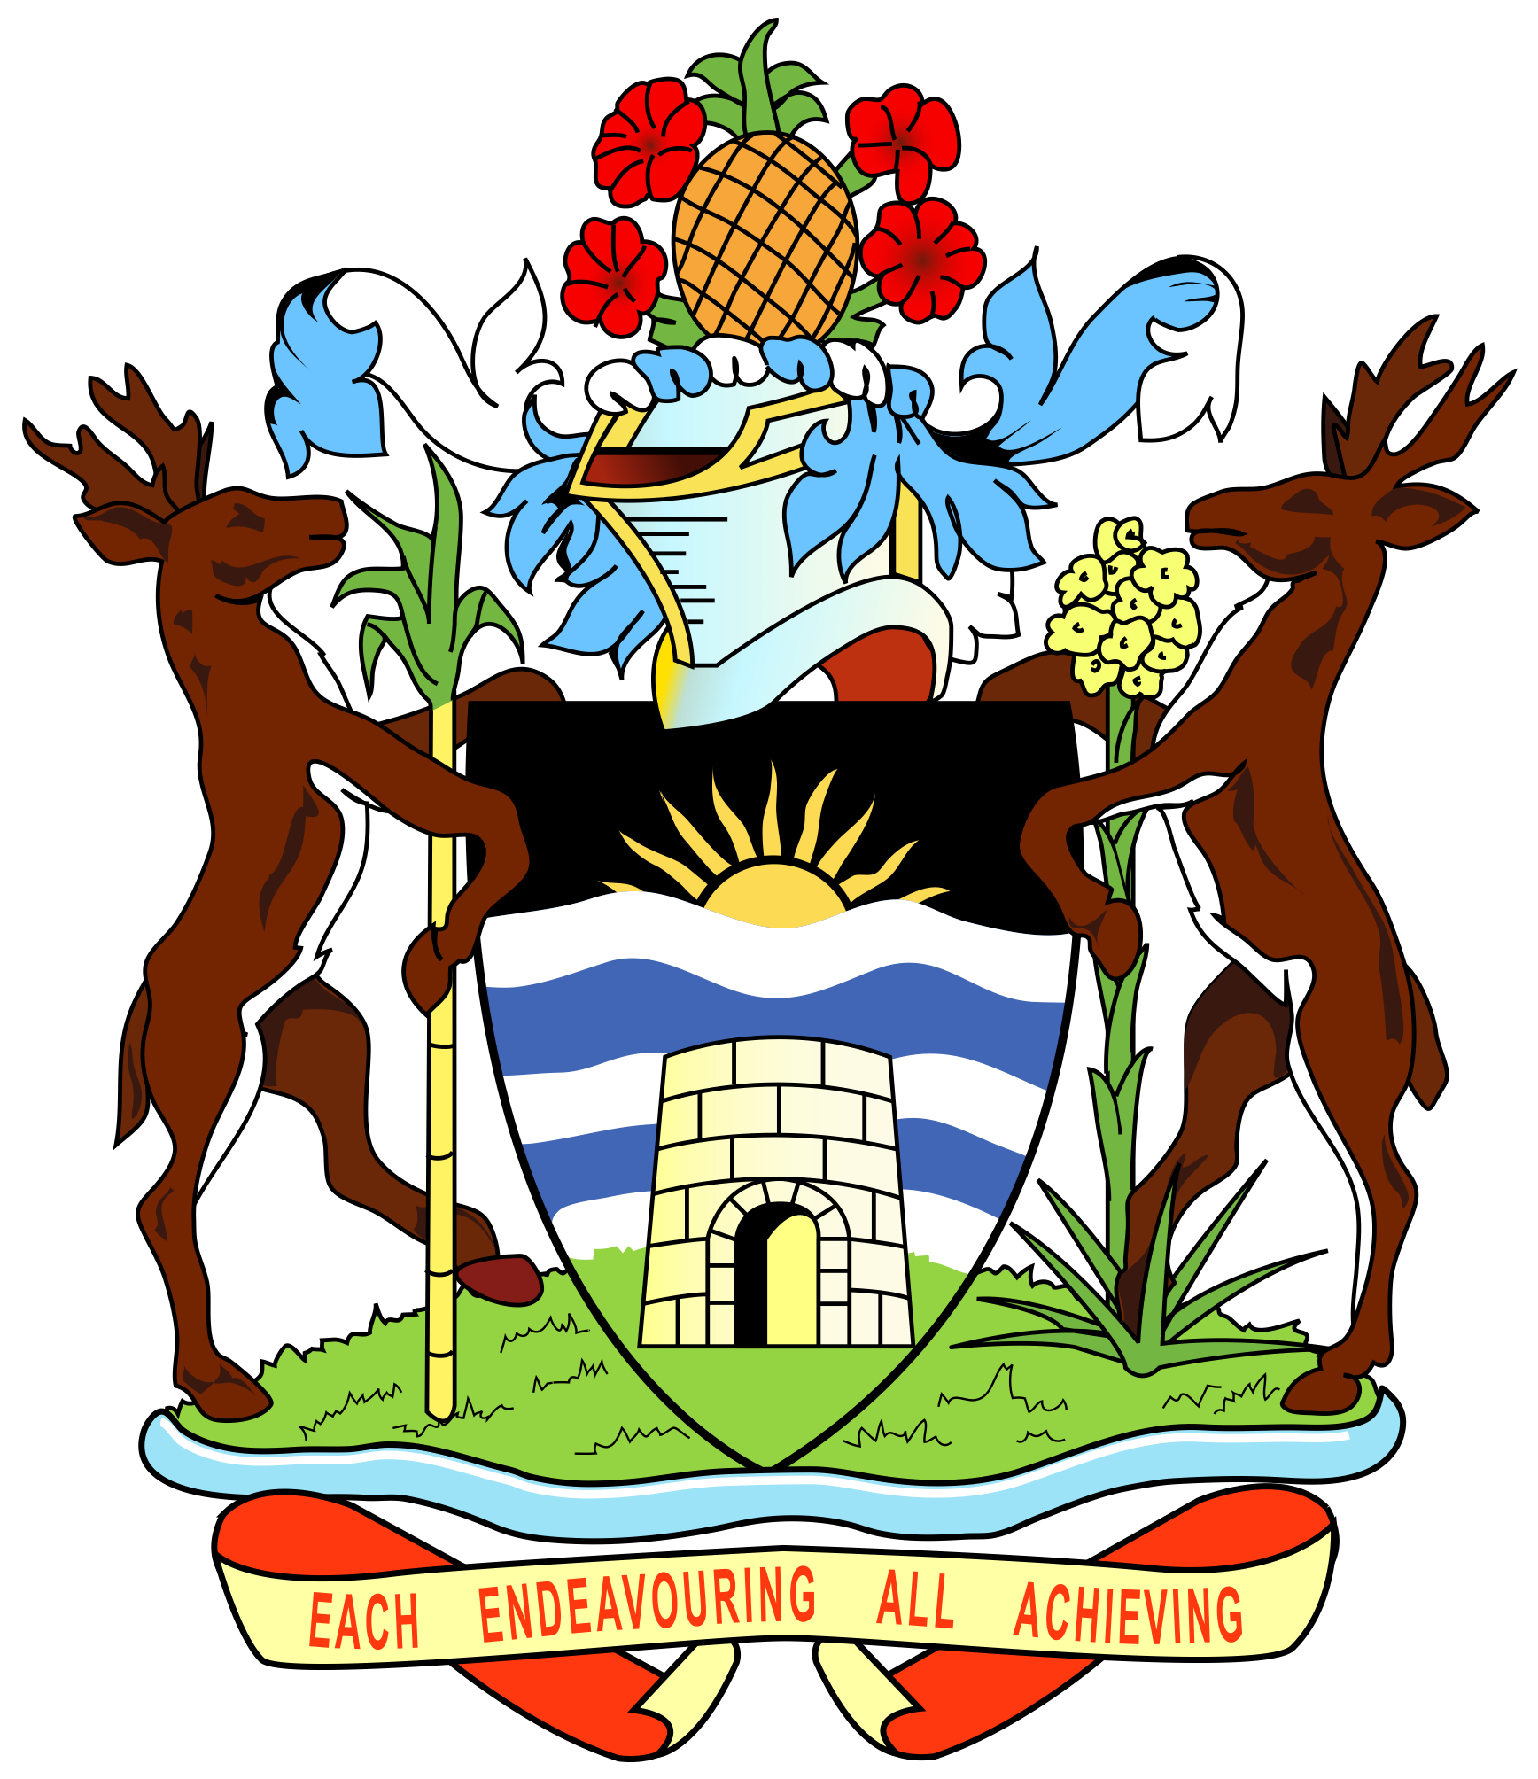

**GOVERNMENT OF ANTIGUA AND BARBUDA**

**45th Session of the Working Group on the Universal Periodic Review**

**UPR of the People’s Republic of China - 23.1.2024**

Thank you, Mr. President.

Antigua and Barbuda welcomes amicably the distinguished delegation from the People’s Republic of China. We would like to express our utmost appreciation for the significant role China played in the global fight against Covid-19, and applaud China’s work to provide equal and universal litigation services through various court reforms.

Antigua and Barbuda would like to propose the following three recommendations to China:

1. Provide further information on the human rights action plans of China in a timely manner and share experiences in advancing human rights work.

2. Continue to accelerate the construction of smart courts

3. promote smart healthcare and deepen the reform of the health system to coordinate the development and governance of health insurance, medical care, and medicine.

We are sincerely grateful for China’s consideration of these recommendations and wish China a successful review.

Thank you, Mr. President.