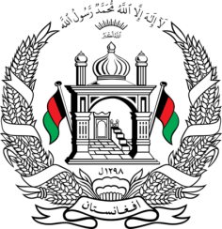
Permanent Mission of Islamic Republic of Afghanistan
45th Session of the UPR Working Group
Statement on the Review of China

Thank you,

Afghanistan welcomes the distinguished delegation of China and thanks them for their detailed presentation of their national report. We note the positive measures taken for the development of economic, social and cultural rights.

In the spirit of constructive engagement, we wish to make the following recommendations :

- Observe the international principle of nonrefoulement and provide protection to migrants and refugees.
- As a member of this Council, ensure that any engagement with the current Taliban de-facto authority in Afghanistan is conditional on respecting and upholding the human rights of the people of Afghanistan, particularly the rights of women and girls, and other vulnerable groups.

Finally, we wish China every success in the implementation of accepted recommendations.

I thank you.

