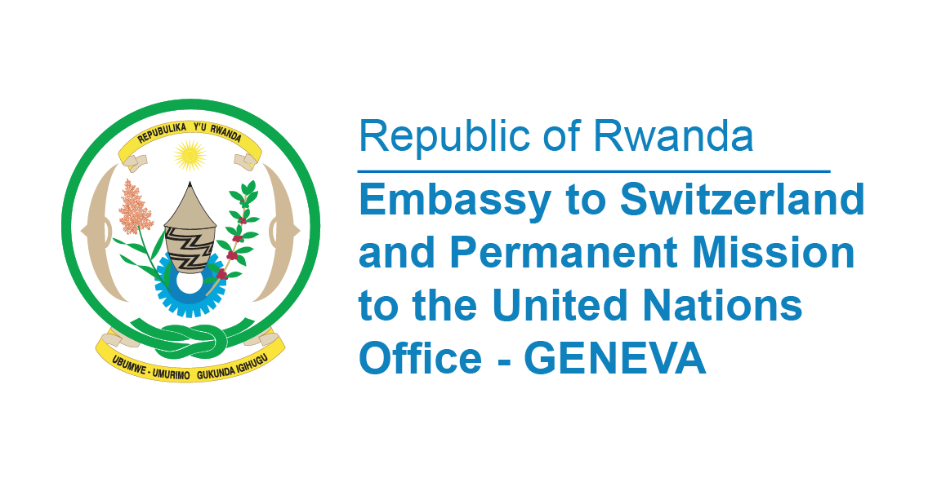

**45th Session of the UPR Working Group**

**Review of Chad**

**30th January 2024**

**Statement delivered by Ms. Betty DUSENGE, Second Counsellor at the Permanent Mission of the Republic of Rwanda**

Thank you, Mr. President,

Rwanda welcomes members the high-level delegation of the Republic of Chad and thanks them for the presentation of a comprehensive National Report.

Rwanda applauds the efforts of the Government of Chad in implementation of the recommendations from her third cycle of the UPR and the set-up of a follow-up plan with the support of the Office of the United Nations High Commissioner for Human Rights.

We noted with appreciation Chad’s continued cooperation with the treaty bodies as witnessed by extending a standing invitation to all special procedures mandate holders and the subsequent two visits.

In a spirit of constructive dialogue, Rwanda recommends to Chad the following;

* Continue the process of establishing a National Human Rights Commission in compliance with the Paris Principle;
* Consider ratifying the Protocol to the African Charter on Human and Peoples’ Rights on the Rights of Women in Africa and the Convention against Discrimination in Education;
* Consider ratifying the Second Optional Protocol to the International Covenant on Civil and Political Rights, aiming at the abolition of the death penalty.

Finally, Rwanda wishes Chad a successful review.

**Thank you**