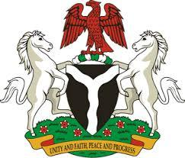

*Please check against delivery*

**HUMAN RIGHTS COUNCIL**

**45TH SESSION OF THE WORKING GROUP OF THE UPR**

**REVIEW OF THE REPUBLIC OF CHAD**

**30TH JANUARY, 2024**

**STATEMENT BY NIGERIA**

**Mr President**,

Nigeria warmly welcomes the delegation from the brotherly Republic of Chad to the presentation of its National Report and commends the Government for its continued cooperation with human rights mechanisms, and efforts in implementing previous recommendations.

2. We are pleased to acknowledge the progress achieved by the Government of Chad in the field of human rights, particularly strident efforts to strengthen its legal and institutional frameworks for the promotion of human rights. We further note with encouragement, the collaborative initiatives undertaken by the Chadian Government, including programs to eradicate child labour, improve children’s access to education and proactive measures to combat terrorism.

3. While recognising the various efforts by Chad to promote and protect human rights, Nigeria wishes to recommend the following:

1. To sustain efforts to combat terrorism; and
2. To intensify efforts to mobilize resources and galvanize international support to enhance its capacity to promote and protect human rights.

4. Finally, we wish the Republic of Chad a very successful review process.

I thank you Mr President.