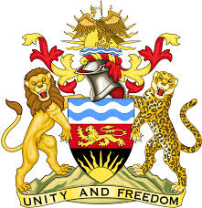

**REPUBLIC OF MALAWI**

**MALAWI STATEMENT ON THE REPUBLIC OF CHAD UNIVERSAL PERIODIC REVIEW**

**TUESDAY, 30TH JANUARY 2024**

**Mr. President**,

Malawi welcomes the Republic of Chad to this review and thanks the delegation for the comprehensive presentation.

We further welcome Chad’s ratification of the Optional Protocol on the Convention on the Rights of Children and continued constructive collaboration with human rights bodies, mechanisms, and relevant special procedures mandate holders.

In the spirit of constructive dialogue, Malawi makes the following recommendations to the Republic of Chad:

1. Consider the ratification of the Convention on the Prevention and Punishment of the Crime of Genocide; and
2. Domesticate the Convention on the Elimination of All Forms of Discrimination Against Women.

We wish the Republic of Chad all the best at this review and in the implementation of the recommendations.

**Thank you, Mr. President**.