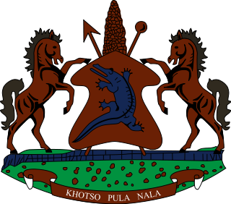

**INTERVENTION OF THE DELEGATION OF LESOTHO DURING THE 4th UPR CYCLE OF CHAD**

**30 JANUARY 2024**

**GENEVA, SWITZERLAND**

Thank you Mr. President,

Lesotho welcomes the distinguished delegation of the Chad to the 4th cycle of the UPR process. We recognise the notable efforts made by Chad, in ensuring constructive collaboration with human rights bodies and mechanisms by extending standing invitations to all special procedures mandate holders and submitting state party report to treaty monitoring bodies. We particularly welcome the ratification of the two Optional Protocols to the Convention on the Rights of the Child.

Lesotho is cognisant of some of the human rights challenges that hinder the full enjoyment of human rights in the country and therefore wishes to make the following recommendations to Chad: 1. To take measures to prohibit corporal punishment in all settings and revise all laws that allow the use of corporal punishment; 2. Accede to the Convention on Enforced Disappearance; and lastly, to continue to undertake public education and campaigns on the dangers of FGM, particularly to church and community leaders who still view FGM as an acceptable cultural practise.

We wish the Chad every success with this UPR cycle

THANK YOU