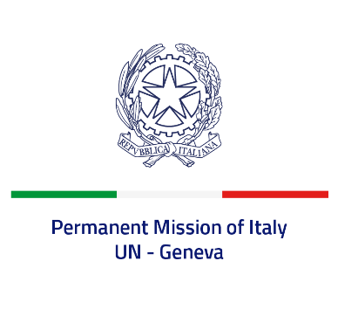

*Check against delivery*

**UPR 45 - Chad**

**Tuesday 30 January 2024, 9:00 - 12:30**

**Delivered by: Ambassador Vincenzo Grassi, Permanent Representative of Italy**

Thank you, Mister President.

We thank the distinguished delegation of Chad for its presentation.

Italy welcomes the abolition of the death penalty for terrorist acts and encourages the ratification of the Second Optional Protocol to the International Covenant on Civil and Political Rights.

We also note with appreciation the ratification of the Convention on the Rights of Persons with Disabilities and the adoption of implementing measures.

Italy seizes this opportunity to offer Chad the following recommendations:

* *Take effective measures to ensure full respect of human rights by security forces and their accountability;*
* *Step up efforts to stop and prevent the recruitment of children by armed groups and to reintegrate them into society;*
* *Continue its commitment to fight all forms of violence against women and girls, particularly sexual violence, female genital mutilation and child, early and forced marriage;*
* *Guarantee full enjoyment of the rights to freedom of expression, association and peaceful assembly, and protect journalists, human rights defenders and NGOs from attacks and intimidation.*

We wish Chad a successful review.

I thank you.