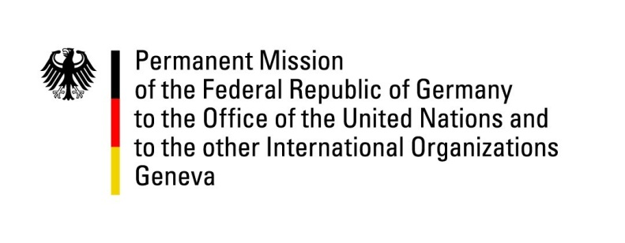

**United Nations Human Rights Council**

**45th Session of the UPR Working Group**

**Geneva, January 30, 2023**

**German Recommendations and advance questions to**

**The Republic of Chad**

Mister (Vice-)President,

Germany welcomes the delegation of the Republic of Chad.

Germany commends Chad for its efforts in the face of the ongoing refugee crisis in the east of the country and encourages further efforts to promote and protect human rights of all asylum seekers, refugees, and internally displaced persons.

However, Germany remains deeply concerned by the lack of progress by the transitional government in fulfilling international human rights obligations. Arbitrary detentions, the amnesty of 20th October including for security forces, and restrictions on civil and political rights give are all cause for concern.

Germany therefore recommends to:

1. Live up to international human rights standards and act in compliance with the international obligations of the ICC Rome Statute and the Convention Against Torture.
2. Repeal the amnesty law of November 2023 with regard to the events of 20th October 2022.
3. Ensure freedom of expression, association and peaceful assembly for all citizens by changing the applicable official regulations to meet human rights law and standards.
4. Implement the National Action Plan on UN Resolution 1325 and amend the Criminal Code to take effective measures on sexual and gender-based violence.

Thank you, Mister (Vice-)President.