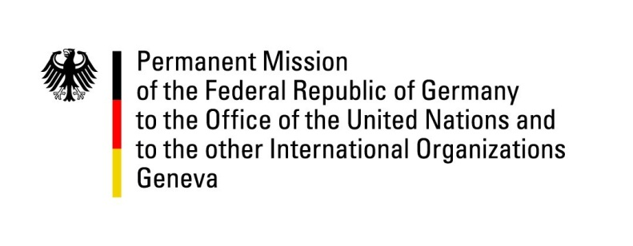

**United Nations Human Rights Council**

**45th Session of the UPR Working Group**

**Geneva, January 29, 2023**

**German Recommendations and advance questions to**

**Belize**

Mister (Vice-)President,

Germany welcomes the delegation of Belize.

Germany commends Belize for its protection of cultural sites through the National Institute of Culture and History (NICH), as well as for the establishment of the National Women's Commission (NWC) in 2022. We also commend Belize for adopting the Belize Refugee (Amendment) Act of 2019 strengthening the protection for refugees.

However, human rights challenges remain, *inter alia* in the area of equal rights and representation of women and LGBTIQ+ persons, as well as concerning a legal framework and treatment of land matters with regards to Indigenous Peoples.

Germany therefore recommends to:

1. transform the Office of the Ombudsman into a national human rights institution (NHRI) with adequate resources;
2. speedily abolish Article 53 of the Criminal Code criminalizing same-sex relations;
3. ratify the Second Optional Protocol to the ICCPR; and
4. ratify the *ILO Indigenous and Tribal Peoples Convention of 1989.*

Thank you, Mister (Vice-)President.