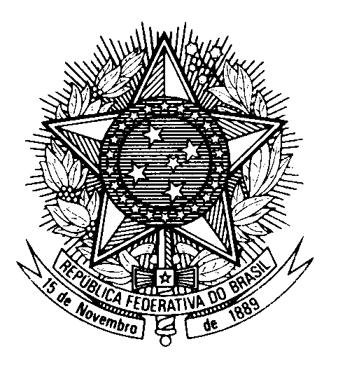

Statement by the Permanent Mission of Brazil to the United Nations in Geneva, in the review of Belize during the 45th session of the Working Group on the Universal Periodic Review

(Geneva, 29 January 2024, 14h30)
1 minute and 50s – 222 words

Brazil welcomes Belize to the UPR.

Brazil congratulates Belize on the progress it has made towards universal access to sexual and reproductive health services, including through the implementation of the National Strategic Plan for HIV/AIDS, STIs, Viral Hepatitis and Tuberculosis, in line with Brazil’s recommendation during the last UPR cycle.

We commend the Supreme Court of Belize for repealing Section 53 of the Penal Code, with a view to decriminalizing consensual same-sex relations. We also commend the country for conducting public awareness campaigns to combat discrimination and violence against LGBTQIA+ persons.

In a constructive spirit, Brazil recommends that Belize:

1. enhance measures to combat sexual and gender-based violence and discrimination, including by effectively implementing the National Gender-based Violence Plan of Action and ensuring equal pay for men and women for work of equal value, and

2. strengthen the protection of children’s rights, in particular by taking measures to eradicate child marriage and child labor and by abolishing all forms of corporal punishment against children in accordance with the provisions of the CRC.

We take due note that the country has been working to review the Refugees Act to ensure that national refugee law comply with international standards.

We encourage Belize to ratify the Inter-American Convention against Racism, Racial Discrimination and Related Forms of Intolerance.

Brazil wishes Belize a successful review.

Thank you.

