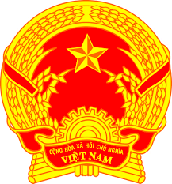

**Statement of the Socialist Republic of Viet Nam**

*44th Session of the UPR Working Group  
Review of Uzbekistan*

*(Geneva, 08 November 2023)*

***Time: 1 minute and 25 seconds***

*Mister President,*

Viet Nam welcomes the delegation of Uzbekistan and thanks them for the comprehensive presentation of the national UPR report.

We commend Uzbekistan for its efforts to strengthen the constitutional and legislative framework and to establish new national mechanisms for the promotion and protection of human rights. We also welcome the actions taken by Uzbekistan to align its national policies with the 2030 Agenda for Sustainable Development.

In a spirit of constructive dialogue, Viet Nam would like to make the following recommendations to Uzbekistan:

First, strengthen measures to improve the quality of education by allocating sufficent resources to the education sector, increasing the number of qualified teachers and improving the quality of educational materials.

Second, take measures to prevent the negative impact of climate change on human rights.

In conclusion, Viet Nam wishes Uzbekistan every success with this UPR cycle.

*Thank you, Mister President./.*