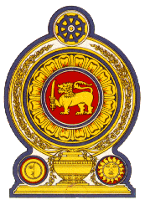

44th Session of the Universal Periodic Review

**Review of Uzbekistan** – 8th November 2023

Statement by the Democratic Socialist Republic of Sri Lanka

Mr. President,

Sri Lanka warmly welcomes the delegation of Uzbekistan and appreciates the presentation made.

Sri Lanka commends the measures taken by Uzbekistan since its last UPR towards strengthening the rule of law, respect for human rights and sustainable development and for the adoption of the new Uzbekistan Development strategy for 2022-2026.

In a constructive spirit, Sri Lanka recommends that Uzbekistan;

1. Continues efforts to uphold the rights of children via the Children’s Rights Ombudsman’s Office, the National Commission on Children and regional commissions and the Public Council for the Protection of Children’s Rights.
2. Ensure access to health-care services to vulnerable groups and work towards the achievement of sustainable development goals related to health.
3. Take measures to improve labour rights and the status of workers, and ensure occupational safety at workplaces.

We wish Uzbekistan success in its UPR engagement.