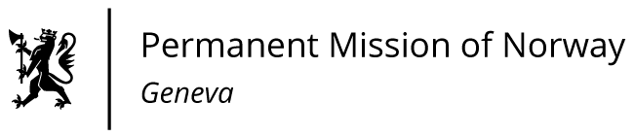

**STATEMENT**

**44th UPR Session of the Human Rights Council**

**on the human rights situation in Uzbekistan,**

**as delivered by Ms Jannicke GRAATRUD**

**Minister, Deputy Permanent Representative of Norway in Geneva.**

Check against delivery

8 November 2023

Vice-President

Norway welcomes the delegation from Uzbekistan and expresses appreciation for the presentation of its national report.  
Norway remains concerned about restrictions on civil society and fundamental freedoms in Uzbekistan.

We have noted with encouragement that a small number of law enforcement officials have been sentenced for abuses during the Karakalpakstan events in 2022. However, a more thorough investigation, also addressing systemic shortcomings, should be carried out.

Norway recommends that Uzbekistan:

1) Sets up a genuinely independent, impartial, and effective committee to broadly investigate human rights violations during the Karakalpakstan events;

2) immediately grant pardons to all journalists, bloggers, and activists and ensure that those who are currently imprisoned are swiftly released and rehabilitated;

3) Adopt an NGO code in line with international standards, with a view to ensuring freedom of association.

I thank you.