*Check against delivery*

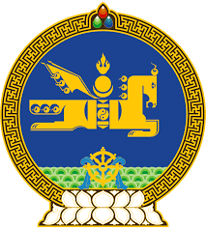

**44th SESSION OF THE UPR WORKING GROUP**

**MONGOLIA’S STATEMENT AT THE REVIEW OF**

**THE REPUBLIC OF UZBEKISTAN**

**8 November 2023**

The delegation of Mongolia warmly welcomes the delegation of the Republic of Uzbekistan to its fourth UPR review and thank them for the presentation of their national report.

Mongolia wishes to congratulate Uzbekistan and the friendly people of Uzbekistan for the adoption of its new Constitution earlier this year through referendum. We are confident that, guided by its new Constitution, Uzbekistan’s vision of “New Uzbekistan” will be realized and for the well-being and full benefit of its people.

My delegation applauds Uzbekistan for its efforts in strengthening the legislative and institutional framework including through adoption of the National Human Rights Strategy, and the National Strategy for Achieving Gender Equality for 2030, as well as for its focus on promoting human rights education through various means.

To complement these encouraging developments, Mongolia would like to recommend the following to the Republic of Uzbekistan:

* To continue its efforts in addressing all forms of violence against women and girls, including gender-based and domestic violence;
* To adopt its draft National Action Plan on Business and Human Rights; and
* To positively consider ratifying the International Convention for the Protection of All Persons from Enforced Disappearance.

We wish Uzbekistan every success during this cycle of the review.

I thank you, Mr. President.

---oOo---