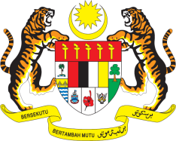

**STATEMENT BY MALAYSIA**

**REVIEW OF UZBEKISTAN**

**44TH SESSION OF THE UPR WORKING GROUP**

**6 – 17 NOVEMBER 2023**

Malaysia thanks Uzbekistan for the presentation of its national report.

2. We congratulate Uzbekistan on the recent adoption of its Constitution for the first time by referendum, reaffirming human rights guarantees and ensuring the continuity of democratic reforms. Malaysia is also encouraged that Uzbekistan has made many important progresses in the areas of the rights of women, children and persons with disabilities.

3. In the spirit of constructive engagement, Malaysia **recommends** the following:

3.1 Continue efforts to align its national human rights institutions with the Paris Principles;

3.2 Take concrete steps to ensure that all victims of gender-based violence, including domestic violence, have access to medical and legal services, including counselling, redress and rehabilitation, as well as to shelters throughout the country; and

3.3 Continue to improve access to basic education for children living in impoverished and rural areas.

4. We wish Uzbekistan a successful review.

Thank you.

**8 NOVEMBER 2023**

**GENEVA**