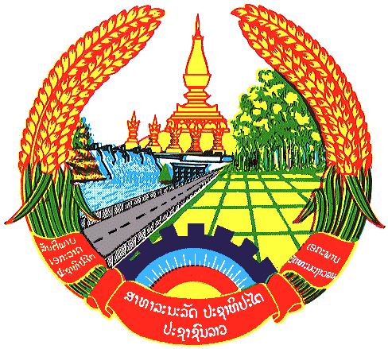

**Statement by the delegation of the Permanent Mission of the Lao PDR to the United Nations and other International Organizations in Geneva**

**at the 44th Session of UPR Working Group**

**Geneva, 8 November 2023**

Review of Uzbekistan (09:00 - 12:30)

1. Mr. President,
2. My delegation warmly welcomes the delegation of Uzbekistan and thanks for the comprehensive report.
3. The Lao PDR commends significant progress made by Uzbekistan in the implementation of the previous UPR recommendations, including the adoption of various national strategies and mechanisms to promote and protect human rights and development in the country. We also welcome Uzbekistan’s ratification of the Convention on the Rights of Persons with Disabilities.
4. The Lao PDR would like to make following recommendations:

* Consider to take further steps to promote and protect the rights of persons with disabilities; and
* Continue efforts to promote gender equality by advancing women’s rights and participation in the society.

1. We wish Uzbekistan every success in this UPR cycle review.
2. I thank you, Mr. President.