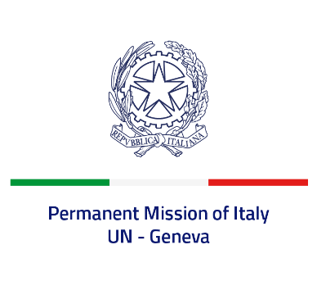

*Check against delivery*

**UPR 44 - Uzbekistan**

**Wednesday 8 November 2023, 9:00 - 12:30**

**Delivered by: Ambassador Vincenzo Grassi, Permanent Representative of Italy**

*(Focal point: Angela Zanca, First Secretary)*

Thank you, Mister President.

We thank the distinguished delegation of Uzbekistan for the presentation.

Italy welcomes the adoption of the National Human Rights Strategy in 2020, as well as the ratification of the Convention on the Rights of Persons with Disabilities in 2021. We encourage Uzbekistan to move forward on the ratification process of the Optional Protocol to the Convention against Torture.

We also take note of the efforts made by Uzbekistan in order to advance women’s rights, in particular the adoption of the National Strategy for Achieving Gender Equality for the period 2020-2030.

Italy seizes this opportunity to offer Uzbekistan the following recommendations:

* *Continue to fight violence against women and consider ratifying the Optional Protocol to the Convention on the Elimination of All Forms of Discrimination against Women;*
* *Enhance efforts to provide a safe and enabling environment for journalists, human rights defenders and NGOs;*
* *Take further measures to promote and protect freedom of religion or belief and to prevent related restrictions and discrimination;*

We wish Uzbekistan a successful review.

I thank you.