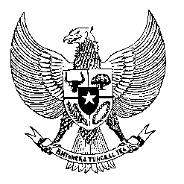

Permanent Mission

of the Republic of Indonesia to the UN, WTO,

and Other International Organizations

in Geneva

**STATEMENT BY THE PERMANENT REPRESENTATIVE OF THE REPUBLIC OF INDONESIA**

**AT THE 44th SESSION OF THE UPR WORKING GROUP - CONSIDERATION OF THE UPR REPORT OF UZBEKISTAN**

**8 NOVEMBER 2023**

**Mr. Vice-President**

• Indonesia thanks the delegation of Uzbekistan for their report.

• Indonesia commends Uzbekistan for expanding institutional mechanisms for human rights protection, including the Children's Rights Ombudsman's Office and National Commission on Children.

• We also welcome the adoption of the Law on criminalizing domestic violence and ratifying the CRPD in 2021.

• In a constructive spirit to support the full realization of human rights in Uzbekistan, Indonesia recommends to:

1. Continue improving the legal and operational environment for NGOs, ensuring their independence and effectiveness.
2. Take measures to expedite the approval and implementation of the National Action Plan for implementing the UNGP on Business and Human Rights.
3. Continue efforts to take legislative measures to ensure freedom of speech and protect journalists, including by continuing a conducive environment for free and independent media.

Finally, we wish the Uzbekistan delegation a very successful review. Thank you.

*.*