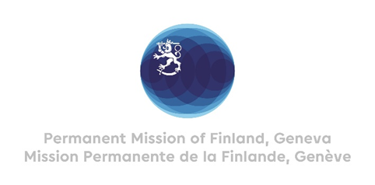

**44 Session of the UPR working group**

**Recommendations by Finland to Uzbekistan**

**7th November 2023**

Mr. President,

Finland welcomes the engagement of Uzbekistan in the UPR. We recognize the steps taken since the last review and commend the forward-looking reform agenda of the government.

Finland recommends the following:

First, to include concrete measures to the reform agenda of the government on further strengthening the freedom of expression by creating an environment in which journalists, independent bloggers and civil society activists can freely operate in accordance with international standards.

Second, to support the respect for the rule of law by strengthening the mandate and independent role of the Ombudsman and the Ombudsman’s office.

Finland wishes Uzbekistan a successful UPR review.

Thank you.