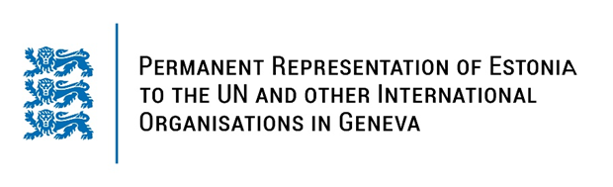

**Universal Periodic Review of Republic of UZBEKISTAN**

**8 November 2023**

**Intervention by the delegation of Estonia**

Estonia warmly welcomes the delegation of the Republic of Uzbekistan to its fourth UPR and thanks for the report and the information provided today.

Estonia commends Uzbekistan for the work undertaken to improve the human rights situation in the country since its last review and welcomes the positive developments regarding cooperation with the UN human rights mechanisms.

Estonia would especially like to express its appreciation for the ratification of the Convention on the Rights of Persons with Disabilities as well as for the adoption of the National Human Rights Strategy. We welcome legislative amendments that criminalize domestic and gender-based violence and we encourage to take necessary steps to ensure the effectiveness of these legal measures.

Estonia remains concerned about restrictions on freedom of opinion and expression and peaceful assembly. In addition, the reports on torture, ill-treatment and excessive use of force during the events in July 2022 continues to raise concerns.

In line with the previous cycle, Estonia recommends to:

# - ratify the Rome Statute of the International Criminal Court (ICC) and the Agreement on the Privileges and Immunities of the International Criminal Court (APIC);

# - ratify the Optional Protocol to the Convention against Torture (OP-CAT)

# - adopt a framework for protecting journalists and media workers from persecution, intimidation, judicial and other forms of harassment and threats, including allowing them to work without government interference.

# - enforce the prohibition of child marriage, including through campaigns and programs to raise awareness of its harmful effects on children, and women and girls in particular.

Estonia would like to wish the delegation of Uzbekistan a successful review meeting.

I thank you.