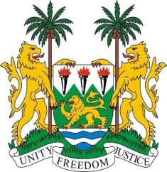

**SIERRA LEONE**

**44th Session of the UPR**

**STATEMENT FOR TUVALU**

Tuesday, 8th November 2023

**Check against Delivery**

**Mr. Vice President**,

Sierra Leone thanks the Attorney General for the presentation of its national report.

Sierra Leone commends Tuvalu for the enactment of the New Constitution of 1st October 2023. We appreciate the inclusive and nationwide consultative process that led to the adoption of this Constitution. We also welcome other legislative improvements, including the ratification of the ILO Worst Forms of Child Labour Convention, 1999.

My delegation commends the government`s “Te Kete” initiative a National Strategic Plan 2020-2030 which aims to achieve sustainable development, reduce poverty, and improve the lives of its people, while adhering to the SDG principle of leaving no one behind. As a small island developing state, we recognise Tuvalu's vulnerability to climate change and other natural disasters. Therefore, we call for global assistance and support to help Tuvalu address these existential threats.

In a spirit of constructive dialogue, we recommend that Tuvalu consider:

1. Provide capacity building and the necessary resources to the National Monitoring, Reporting and Follow-up Mechanism to enable it to fulfil its mandate.
2. Consider ratifying the six remaining core human rights treaties: ICCPR, ICESCR, CAT, CED, CERD and CMW.
3. Facilitate a survivor-centered awareness-raising campaign to address social norms related to gender-based and domestic violence.
4. Review the functioning of the Office of the Ombudsman and provide it with the necessary resources to ensure that it is fit for purpose.
5. Ratify the Optional Protocol to the CRC with a view to eliminate the sale of children, child prostitution and child pornography**.**

Sierra Leone wishes Tuvalu every success in the completion its fourth review cycle.

I thank you Mr. Vice President.