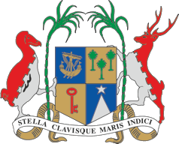

**EMBASSY OF THE REPUBLIC OF MAURITIUS & PERMANENT MISSION TO THE UNITED NATIONS AND OTHER INTERNATIONAL ORGANISATIONS**

**AMBASSADE DE LA REPUBLIQUE DE MAURICE ET MISSION PERMANENTE AUPRES DES NATIONS UNIES   
ET DES AUTRES ORGANISATIONS INTERNATIONALES**

**CONSIDERATION OF THE UNIVERSAL PERIODIC REVIEW OF TUVALU**

**8 NOVEMBER 2023**

Mr. President,

Mauritius extends a warm welcome to the delegation of Tuvalu for this fourth UPR.

Mauritius understands the inherent difficulties faced by Tuvalu as a Small Island Developing State namely challenges which span climate issues and their impact on livelihoods, food insecurity and health issues of a non-communicable nature. In the face of these challenges, we commend Tuvalu for the maintenance of its free Public Health System, its low Covid 19 death rate, declining infant mortality rate and the post-natal health care for mothers. We also commend it for continuing to uphold Human Rights and making effort to make education more accessible to all.

In a constructive spirit, we recommend that the Tuvalu government:

1. Pursue efforts to operationalise its national human rights institutions.
2. Work with the UNESCO to ensure that the right to education is guaranteed in its constitution.

Thank you, Mr. President.