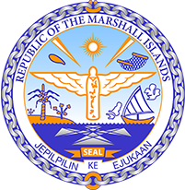

Republic of the Marshall Islands
STATEMENT by Mr. Samuel Lanwi Jnr
44th Session Universal Periodic Review
8th November 2023
Geneva

4th Cycle Review of Tuvalu

Mr. Vice President,

The Marshall Islands warmly welcomes the delegation of Tuvalu to this 4th UPR cycle. We commend Tuvalu for its regional and global leadership on climate change and its efforts to implement its National Climate Change Policy 2020-2030.

As a fellow Pacific SIDS, we share similar challenges and lived realities where climate change is concerned, particularly as climate-induced sea-level rise continues unabated due to the reckless abandonment by high emitters for the existential threat that climate change poses to low-lying atoll nations.

We firmly believe that Tuvalu has a powerful story and voice that should be heard more often in the Human Rights Council and in other UN bodies and technical agencies based here in Geneva.

In a constructive spirit, we therefore offer the following 2 recommendations for Tuvalu’s consideration:

- Consider establishing a permanent mission to the United Nations Office in Geneva.

- Ratify the Convention against Torture and Other Cruel, Inhuman or Degrading Treatment or Punishment.

We wish the delegation every success during its 4th UPR cycle.

Kommol tata and I thank you Mr. Vice President.

