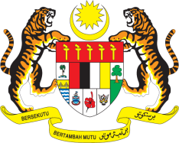

**STATEMENT BY MALAYSIA**

**REVIEW OF TUVALU**

**44TH SESSION OF THE UPR WORKING GROUP**

**6 – 17 NOVEMBER 2023**

Malaysia thanks Tuvalu for the presentation of its national report and welcomes the positive steps taken by the Government of Tuvalu to implement recommendations it had accepted at the last UPR session.

1. We also commend Tuvalu for its strong commitment towards promoting human rights including protecting women from violence and discrimination.
2. In the spirit of constructive engagement, Malaysia **recommends** the following:

3.1 Continue efforts to empower women to ensure better representation of women in political and public positions with the objective to further integrate them into policymaking and implementation;

3.2 Increase partnerships to ensure access to quality education for all, including by providing and improving resources such as teacher training, classroom equipment, and school infrastructure; and

3.3 Continue cooperation with the United Nations mechanisms for the promotion and protection of human rights through an institutionalised approach.

1. We wish Tuvalu a successful review.

Thank you.

**8 NOVEMBER 2023**

**GENEVA**