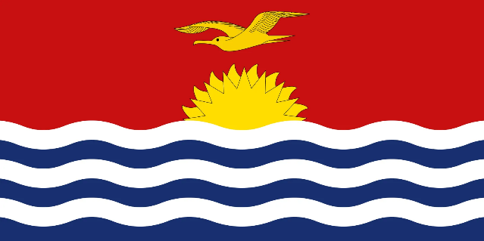

**STATEMENT BY KIRIBATI, DURING THE 44TH SESSION OF THE UPR WORKING GROUP ON WEDNESDAY, 8TH NOVEMBER 2023**

**UNIVERSAL PERIODIC REVIEW OF TUVALU**

Thank you, Mr. President/Vice President,

Kiribati warmly welcomes the delegation from Tuvalu to the fourth cycle of UPR and wish to extend an appreciation for the delegation’s comprehensive report and the commitment of the government of Tuvalu to the UPR process

We congratulate Tuvalu for being the first Pacific Country to launch the National Human Rights Action Plan which confirms and outlines the country’s commitments to the protection and promotion of Human Rights in Tuvalu.

We also acknowledge and commend the government of Tuvalu for the efforts made towards its obligations under the various Human rights instrument, particularly, for ensuring the promotion and protection of the most vulnerable groups such as women, children, person with disability and elderly persons.

**In the spirit of constructive engagement, Kiribati would like to recommends to Tuvalu the following recommendations;**

1. To ratify the UN Convention Against Torture and other Cruel Inhuman or Degrading Treatment or Punishment
2. To consider ratifying the two optional protocols on the Convention on the Rights of the Child

Kiribati wishes the delegation of Tuvalu every success in the UPR cycle.

Thank you, Mr President/Vice President,