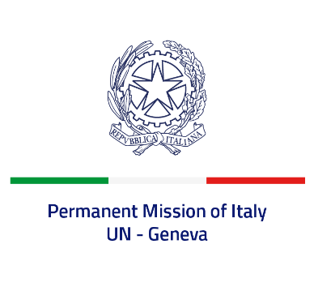

*Check against delivery*

**UPR 44 – Tuvalu**

**Wednesday 8 November 2023, 14:30 - 18:00**

**Delivered by: Permanent Representative of Italy Amb. Vincenzo Grassi**

*(Focal point: Andrea Lacroce, Second Secretary)*

Thank you, Mister President.

We thank the distinguished delegation of Tuvalu for their national report and presentation.

Italy welcomes the ratification of the ILO Convention C182 on the Worst Forms of Child Labour in June 2019, as well as the measures taken to develop a national disability policy.

We also welcome the repeal of corporal punishment of child offenders in national legislation.

Italy would like to recommend to:

* *Consider adopting and ratifying the main international human rights instruments, especially the ICCPR, the ICESCR and the Convention against torture and other cruel, inhuman and degrading treatments or punishment.*
* *Ensure the full enjoyment of the right to education to all girls and promote women empowerment and gender equality.*
* *Improve access to health care, in particular for vulnerable persons.*

We wish the delegation of Tuvalu a successful review.