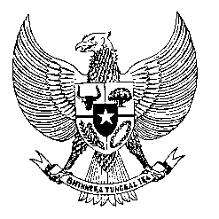

Permanent Mission

of the Republic of Indonesia to the UN, WTO,

and Other International Organizations

in Geneva

**STATEMENT BY THE DELEGATION OF THE REPUBLIC OF INDONESIA**

**AT THE 44th SESSION OF THE UPR WORKING GROUP**

**CONSIDERATION OF THE UPR REPORT OF TUVALU**

**8 NOVEMBER 2023**

**Thank you, Mr. VICE-President**

Indonesia welcomes Tuvalu’s comprehensive national report.

We welcome Tuvalu’s new constitutional amendments that came into effect on the 1st of October 2023, right on Tuvalu’s 45th Independence Day. We commend the work of the Government of Tuvalu in reviewing its constitution through an inclusive and aspiring 7-year process.

My delegation also sees the significant importance and merit of Tuvalus’s “TE KETE” National Strategy for Sustainable Development 2021-2030. Indeed, it is important to put traditional knowledge and wealth as the core of development.

To further support Tuvalu’s efforts in promoting and protecting human rights of its people, Indonesia recommends:

1. To further ratify more international human rights treaties including, but not limited to, the UN Convention against Torture and Other Cruel, Inhuman or Degrading Treatment or Punishment; the International Covenant on Civil and Political Rights; the International Covenant on Economic, Social, and Cultural Rights; as well as the United Nations Convention Against Transnational Organized Crime
2. Continue working with relevant stakeholders in order to improve access to quality education.

Finally, we wish Tuvalu a successful review.

Thank you.

*Word Count: 180 words*

*Max. Speaking Time: 2 minute*