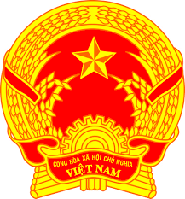

**Statement of the Socialist Republic of Viet Nam**

*44th Session of the UPR Working Group  
Review of Turkmenistan*

*(Geneva, 06 November 2023)*

***Time: 1 minute 30 seconds***

*Madam Vice President,*

Viet Nam welcomes and thanks the delegation of Turkmenistan for the national UPR report. We wish Turkmenistan every success with this UPR cycle.

We welcome Turkmenistan’s adoption and implementation of its National Programme of Socio-economic Development for the period of 2022-2052, which prioritizes the ever-increasing role of human capital as the main factor for the country’s economic development and the formation of a new social model of development to ensure a high standard of living for the people of Turkmenistan. We also take note of the progress of Turkmenistan in implementing the SDGs.

In a spirit of constructive dialogue, Viet Nam makes two recommendations to Turkmenistan:

First, pursue efforts to bring the national legislation in line with Turkmenistan’s international human rights obligations.

Second, continue to take effective measures to ensure the inclusion of persons with disabilities in the open labour market.

*I thank you./.*