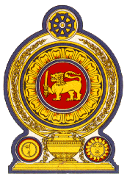

**44th Session of the Universal Periodic Review**

**Review of Turkmenistan**

**06 November 2023**

**Statement by the Democratic Socialist Republic of Sri Lanka**

Mr President,

Sri Lanka extends a warm welcome to the delegation of Turkmenistan and appreciates the presentation made.

We commend Turkmenistan’s progress in protecting and promoting human rights since its last UPR. Sri Lanka notes with appreciation the progressive policies implemented including the National Action Plan on Gender Equality 2015-2020, and 2021-2025, and the National Human Rights Action plan 2021-2025.

In a constructive spirit, Sri Lanka recommends that Turkmenistan:

-Ratifies the Convention on the protection of the Rights of All Migrant Workers and Members of Their families

-Continues to advance the rights of women and their participation in public policy decision making

We wish Turkmenistan success in its UPR engagement.