*Check against delivery*

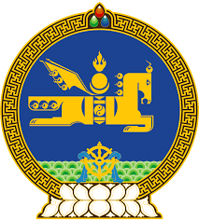

**44th SESSION OF THE UPR WORKING GROUP**

**MONGOLIA’S STATEMENT AT THE REVIEW OF TURKMENISTAN**

**6 November 2023**

The delegation of Mongolia warmly welcomes the delegation of Turkmenistan to the 4th cycle of the UPR process and thank them for the presentation of their national report today.

Mongolia welcomes Turkmenistan’s efforts in strengthening its legal and institutional framework for the protection and promotion of human rights in line with international human rights and labour standards. We note with appreciation its endeavors aimed at ensuring gender equality and empowering women and girls. Adoption of theNational Plan of Action for Gender Equality and the second National Action Plan on Human Rights for 2021–2025, respectively, is particularly welcome in this regard.

We further commend Turkmenistan for its measures towards safeguarding the rights of persons in vulnerable situations- persons with disabilities, the elderly, children and youth, single mothers, and victims of domestic violence, including through implementing inclusive, community-based quality social services.

In the spirit of constructive dialogue, Mongolia would like to recommend Turkmenistan:

* To continue strengthening its Office of the Ombudsperson in line with the Paris Principles; and
* To positively consider ratifying the International Convention for the Protection of All Persons from Enforced Disappearance.

We wish the delegation of Turkmenistan a successful review.

I thank you, Mr. President.

---oOo---