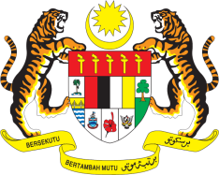

**STATEMENT BY MALAYSIA**

**REVIEW OF TURKMENISTAN**

**44TH SESSION OF THE UPR WORKING GROUP**

**6 – 17 NOVEMBER 2023**

Malaysia thanks Turkmenistan for the presentation of its national report.

2. We commend Turkmenistan for ratifying several international instruments following its Third UPR Cycle. We also welcome the adoption of various National Action Plans, including the National Action Plan for the Realisation of Children's Rights and the National Action Plan for Countering Trafficking in Persons.

3. Furthermore, we appreciate Turkmenistan's dedication to enhancing transparency and combatting corruption through the digitalisation of public services via the "e-Government" initiative.

4. In the spirit of constructive engagement, Malaysia **recommends** the following:

4.1 Continue to enhance transparency in public services and to strengthen its legal and policy framework to eradicate corruption;

4.2 Continue taking steps to ensure vulnerable groups and those living in poverty are given adequate access to employment, health, education and social services; and

4.3 Continue taking steps to address food insecurity including by developing a comprehensive database.

5. We wish Turkmenistan a successful review.

Thank you.

**6 NOVEMBER 2023**

**GENEVA**