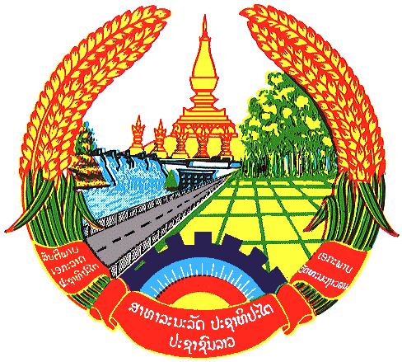

**Statement by the delegation of the Permanent Mission of the Lao PDR to the United Nations and other International Organizations in Geneva**

**at the 44th Session of UPR Working Group**

**Geneva, 6 November 2023**

Review of Turkmenistan (09:00 - 12:30)

1. Mr. President,
2. My delegation warmly welcomes the delegation of Turkmenistan and thanks for a comprehensive presentation of the national report.
3. The Lao PDR commends Turkmenistan’s concrete efforts to implement the previous UPR recommendations by taking steps and national measures to improve legal and institutional frameworks and strengthen cooperation with the UN human rights mechanisms. My delegation also welcomes the achievements made towards implementing the SDGs contributed to improve human rights and wellbeing of all citizens in the country.
4. The Lao PDR would like to make following recommendations:

* Strengthen efforts towards achieving and fully implementing the National Human Rights Actions Plan 2021-2025.
* Continue its constructive engagement and cooperation with the international human rights mechanisms to promote and protect all human rights in the country.

1. We wish Turkmenistan every success in its Fourth Cycle of UPR.
2. I thank you, Mr. President.