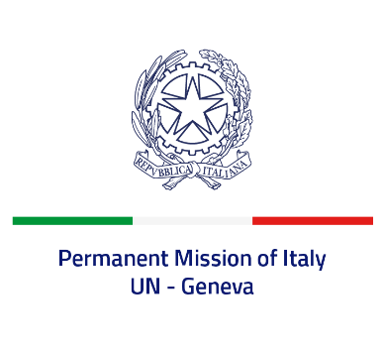

*Check against delivery*

**UPR 44 – Turkmenistan**

**Monday 6 November 2023, 9:00 – 12:30**

**Delivered by: Permanent Representative of Italy Amb. Vincenzo Grassi**

*(Focal point: Daniele Borrelli, First Counsellor)*

Thank you, Mister President.

We thank the distinguished delegation of Turkmenistan for their national report and presentation.

Italy welcomes the efforts at national level to strenghten the protection of human rights, including with regard to gender equality and the rights of female workers. We also welcome the increased attention devoted to the prevention of torture and other forms of inhuman treatment.

Italy would like to offer the following recommendations:

* *Further enhance efforts to combat and address cases of torture and enforced disappearances as well as to guarantee human rights and fundamental freedoms of prisoners and detainees.*
* *Protect and promote the rights to freedom of expression, association and peaceful assembly.*
* *Take effective measures to prevent and fight all forms of discrimination, including when based on gender and sexual orientation.*

We wish the delegation of Turkmenistan a successful review.

I thank you.