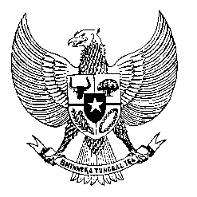

Permanent Mission

of the Republic of Indonesia to the UN, WTO,

and Other International Organizations

in Geneva

**STATEMENT BY THE DELEGATION OF THE REPUBLIC OF INDONESIA**

**AT THE 44th SESSION OF THE UPR WORKING GROUP**

**CONSIDERATION OF THE UPR REPORT OF TURKMENISTAN**

**6 NOVEMBER 2023**

**Thank you Madam Vice President**

Indonesia expresses its appreciation to the delegation of Turkmenistan for presenting its report.

We applaud Turkmenistan for having ratified a number of international legal instruments and submitting national reports on implementation of several core international human rights instruments, since its last UPR.

This important achievement signifies Turkmenistan’s strong commitment to improving the realization of human rights in its country.

To further support Turkmenistan in making progress in the promotion and protection of human rights, Indonesia recommends to:

1. Continue efforts to strengthen the institutional capacity and competence of the Office of the Ombudsperson in Turkmenistan for accreditation by the GANHRI.
2. Expedite the work towards early adoption of the National Action Plan to Combat Trafficking in Persons 2023–2025 and its effective implementation.
3. Take further steps to ratify the International Convention on the Protection of the Rights of all Migrant Workers and Members of Their Families.

Finally, we wish Turkmenistan a successful review.

Thank you.

*Word Count: 157 words*

*Max. Speaking Time: 1 minute 30 seconds*