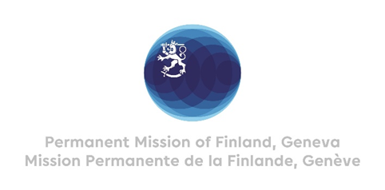

**44 Session of the UPR working group**

**Recommendations by Finland to Turkmenistan**

**6th November 2023**

Mr. President,

Finland welcomes the engagement of Turkmenistan in the UPR.

In the spirit of constructive dialogue, Finland recommends the following:

Firstly, to guarantee the right to access of information, in particular by ensuring unhindered access to internet for all.

Secondly, to develop and implement a national strategy to secure the rights of persons with disabilities.

Thirdly, to support the respect for the rule of law by strengthening the mandate and independent role of the Ombudsman and the Ombudsman’s office.

Finland wishes Turkmenistan a successful UPR review.

Thank you.