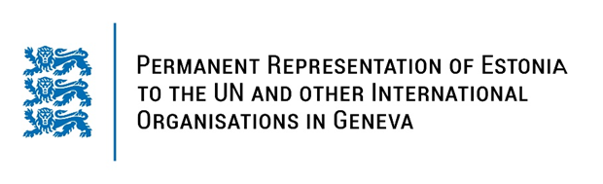

**Universal Periodic Review of TURKMENISTAN**

**6 November 2023**

**Intervention by the delegation of Estonia**

Estonia warmly welcomes the delegation of Turkmenistan to the country’s fourth UPR and thanks for the report and the information provided today.

Estonia would like to recognize Turkmenistan’s efforts to advance human rights, including by adopting several thematic action plans. We welcome Turkmenistan efforts for reducing preventable maternal mortality.

However, despite some progress, gender gaps, gender-based violence and disadvantageous social norms facing women and girls persist. We also remain concerned about the constraints to individual liberties, including rolling back on freedom of opinion and expression and media freedom. We encourage Turkmenistan to cooperate fully with the UN special procedures mandate holders.

In line with the previous cycle, Estonia would like to recommend to the Government of Turkmenistan to:

# - ratify the Rome Statute of the International Criminal Court (ICC) and the Agreement on the Privileges and Immunities of the International Criminal Court (APIC);

# - ratify the Optional Protocol to the Convention against Torture and Other Cruel, Inhuman or Degrading Treatment or Punishment (OP CAT);

In addition, we recommend to:

# - take steps to decriminalize abortion;

# - guarantee universal access to sexual and reproductive health as a part of universal health coverage and to affordable modern contraceptives and emergency contraception to all women and girls;

# - amend existing legislation to ensure adequate provisions against gender-based violence in accordance with international standards.

We wish the delegation of Turkmenistan a successful review and effective implementation of accepted recommendations.

Thank you.