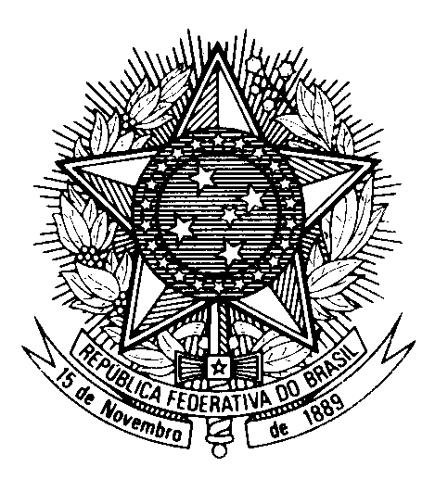

Statement by the Permanent Mission of Brazil to the United Nations Office in the review of Turkmenistan, during the 44th session of the Working Group on the Universal Periodic Review

(Geneva, 6 November 2023)

Mr. President,

Brazil welcomes the Turkmen delegation to the 4th cycle of the UPR and thanks them for their presentation.

We praise the Turkmenistan`s commitment towards the ratification of international human rights conventions, such as ILO Conventions, the Convention against Discrimination in Education and the Convention on the Prevention and Punishment of the Crime of Genocide.

Brazil encourages Turkmenistan to continue to pursue its efforts to guarantee the most comprehensive coverage and the highest possible quality of education for all, including girls and children with disabilities.

In a spirit of constructive engagement, Brazil recommends Turkmenistan:

(1) To decriminalize consensual same-sex relationships; and

(2) To fully implement the constitutional provisions guaranteeing freedom of opinion, thought and expression, including by ensuring unobstructed Internet access to news websites and social networks.

Thank you.

