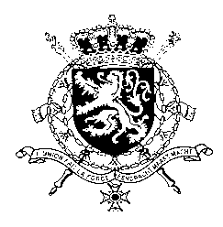
Représentation permanente de la Belgique auprès des Nations Unies et auprès des institutions spécialisées à Genève

WG UPR 44 – Turkmenistan
Intervention of Belgium
6 November 2023

President,

Belgium welcomes the delegation of Turkmenistan and wishes it every success in the exercise of its fourth UPR. While acknowledging progress made in some areas since its previous UPR, we are convinced that further progress can be achieved to increase the protection of human rights in line with the core international human rights treaties.

Therefore, we would like to formulate the following recommendations:

R1. Allow independent monitors, journalists and human rights defenders to document and report on the situation on child and forced labor in the cotton harvest without fear of reprisal.

R2. Guarantee the right to freedom of expression, association and peaceful assembly and refrain from intimidation, arbitrary restrictions and detention of civil society members and their relatives who peacefully exercise these rights.

R3. Ensure that prompt, thorough, independent and impartial criminal investigations are conducted into alleged disappearances and that victims of enforced disappearance, including their families, are provided with full and effective reparation and rehabilitation.

Thank you, President.

