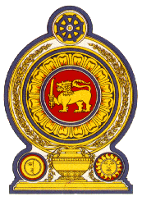

**Statement by the Democratic Socialist Republic of Sri Lanka**

**44th Session of the Universal Periodic Review**

**Review of Russia – 13 November 2023**

Mr. President,

Sri Lanka appreciates the presentation of national report by the Russian Federation at its 4th UPR review. We commend the cooperation by the Russian Federation with Human Rights mechanisms including its compliance with treaty body reporting during the period under review.

We appreciate the measures taken by the Russian Government to enhance the protection and promotion of rights as well as welfare of vulnerable groups.

Sri Lanka wishes to recommend that the Russian Federation:

1. Consider acceding to the International Convention on the Protection of the Rights of All Migrant Workers and Members of their Families;
2. Consider acceding to the Optional Protocol to the Convention against Torture and other Cruel, Inhuman or Degrading Treatment or Punishment and continue to improve the legislation in the area of combatting torture, degrading treatment and punishment.
3. Continue to enhance the cooperation with international human rights bodies and participate in the international exchange of best practices in promoting and protecting human rights
4. Continue to take measures to improve the quality of life for elderly people and people with disabilities and to increase employment opportunities for people with disabilities and promote their recruitment.

Sri Lanka wishes the Russian Federation success in its UPR engagement.

Thank you.

(1 minute)