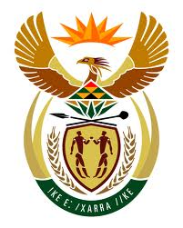

**SOUTH AFRICAN PERMANENT MISSION**

**TO THE UNITED NATIONS**

**AND OTHER INTERNATIONAL ORGANISATIONS**

**44TH SESSION OF THE WORKING GROUP ON THE**

**UNIVERSAL PERIODIC REVIEW**

**Review of THE RUSSIAN FEDERATON**

**13 NOVEMBER 2023**

**(60 Seconds)**

**speaker no: 69**

***Check against delivery***

Mr. President,

South Africa welcomes the distinguished delegation of the Russian Federation to this UPR Session.

South Africa commends the Russian Federation’s approval of the National Women’s Strategy, which sets out the country’s policy to advance the interests of women. We acknowledge the efforts undertaken to increase access to education, including pre-school education as well as medical care through the expansion of the State guarantee programme.

South Africa wishes to make the following recommendations:

* Ratify the Optional Protocol to the Convention on the Rights of Persons with Disabilities;
* Accelerate the adoption of a federal act on the mandate of the country’s national human rights institution, ensuring it accords with the Paris Principles;
* Strengthen measures to improve conditions of detention to comply with the Nelson Mandela Rules and ensure the independent monitoring of all associated facilities; and
* Amend the Criminal Code to explicitly criminalise marital rape and adopt federal legislation prohibiting domestic violence.

South Africa wishes the Russian Federation a successful review.

I thank you.