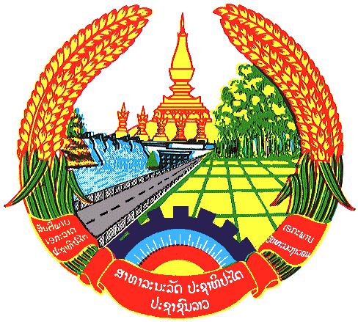

**Statement by the delegation of the Permanent Mission of the Lao PDR to the United Nations and other International Organizations in Geneva**

**at the 44th Session of UPR Working Group**

**Geneva, 13 November 2023**

Review of Russia (14:30 - 18:00)

1. Thank you, Mr. President, for the floor.
2. The Lao PDR warmly welcomes the delegation of Russia and thanks for the comprehensive presentation of the national report.
3. My delegation commends Russia for its cooperation and engagement with the UN human rights mechanisms, including the Universal Periodic Review, which is the most optimal procedure to promote human rights.
4. In this constructive spirit, the Lao PDR would like to make the following recommendations:

* Continue to take measures to improve the quality of life for the marginalized groups of people such as elderly and people with disabilities; and
* Continue to enhance the cooperation with international partners in the human rights field.

1. We wish Russia every success in this UPR cycle review.
2. I thank you, Mr. President.