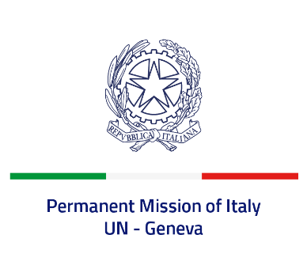

*Check against delivery*

**UPR 44 – Russian Federation**

**Monday 13 November 2023, 14:30 – 18:00**

**Delivered by: Permanent Representative of Italy Amb. Vincenzo Grassi**

Thank you, Mister President.

We thank the distinguished delegation of the Russian Federation for their national report and presentation.

Italy would like to offer the following recommendations:

* *Guarantee freedom of expression, both online and offline, in particular for human rights defenders and journalists, as well as freedom of association, right to peaceful assembly and political pluralism.*
* *Put an end to all acts of torture, enforced disappearances, extrajudicial executions as well as arbitrary detentions, and release all those detained for exercising their rights to freedom of expression or association.*
* *Ensure the respect of the rule of law, including the independence of the judiciary, and guarantee the rights of detainees.*
* *Combat all forms of discrimination and violence.*
* *End the war of aggression in Ukraine and ensure the full respect of all human rights in the Ukrainian occupied territories.*
* *Ratify the Rome Statute of the ICC.*

We wish the delegation of the Russian Federation a successful review.

I thank you.